## Updating the Online Database Site

Since the previous iteration of this project used the Dreamweaver software to generate the original website, we chose to do so as well. The first order of business was to design a unified look for all the pages of the site in order to give it a slightly more professional and streamlined look. For this purpose, we used Dreamweaver’s “Template” feature to create a template containing the site’s banner and navigation buttons, which could be applied to each of the content pages. The following images show the two templates main that were used on the new version of the site:

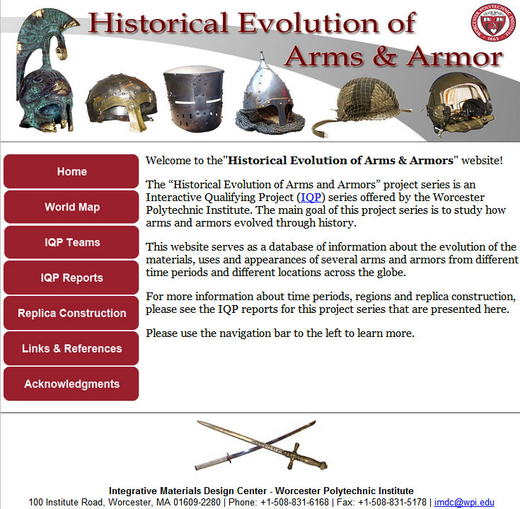

Figure 50: New Website Main Template with Sidebar Navigation.

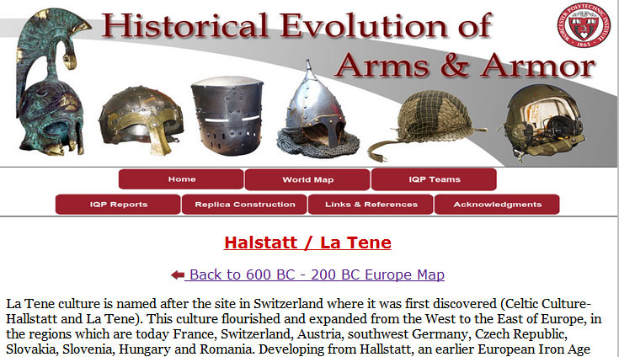

Figure 51: More Spacious Template with Top Navigation.

The first template was used for general pages, such as the main page, the reports page and other pages that had only a small amount of content. The second template was used on all the pages that require more space to fit their large amounts of content. These include the map pages for each region and the specific arms and armors pages. An example of a map with period navigation at its top can be seen below.

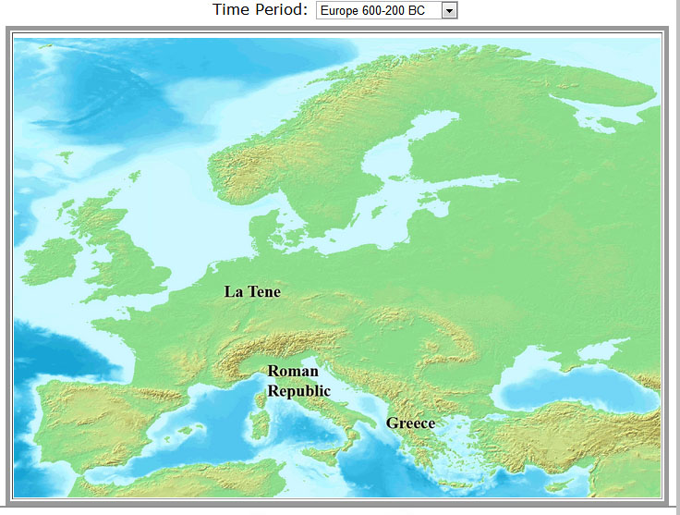

Figure 52: Clickable Map and Navigable Time Periods Example.

Each of the black labels in the above map is clickable and leads to the arms and armors page for the specific area the label is associated with. This functionality is a carry-over from the previous iteration of the site, but the size and quality of the maps have been standardized to maintain the same look throughout the entire page.

As a final note the site as a whole is relatively “low tech”, using only Dreamweaver features and HTML. However, some scripts and more advanced features were used in order to enhance the site. For instance, in order to keep all the files associated with the templates in one folder and to make the code slightly more general, a Javascript script file was placed in each sub-folder that contains content pages. This script file tells the page where its root directory lies, such that the site can always find its main directory and the templates folder therein. In addition, special code was added in order to implement the opening lists, which unfold the lists of team members in the Teams page and the listed reports per year in the IQP Reports page.